Experiment 1: Full Wave Rectifier
COMMON MISTAKES
- DO NOT GROUND THE POINT IN RED.
- If the red point is grounded, it can burn the circuit.

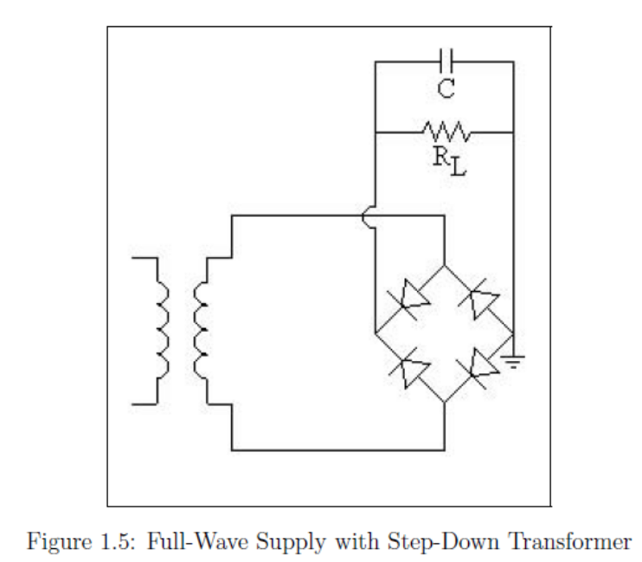
Only this point is to be grounded
DO NOT GROUND THIS POINT

Points to Note –
- Ripple voltage magnitude ~ 20mV.
- In order to see the ripple on the oscilloscope, set the scope on AC Coupling
- Set the Probe value to 1:1
- Set the trigger value to less than 20mV.
Note – Make sure that all the grounds are connected to the same point.

EXPERIMENT 2: Dual Power Supply with Center Tap Transformer
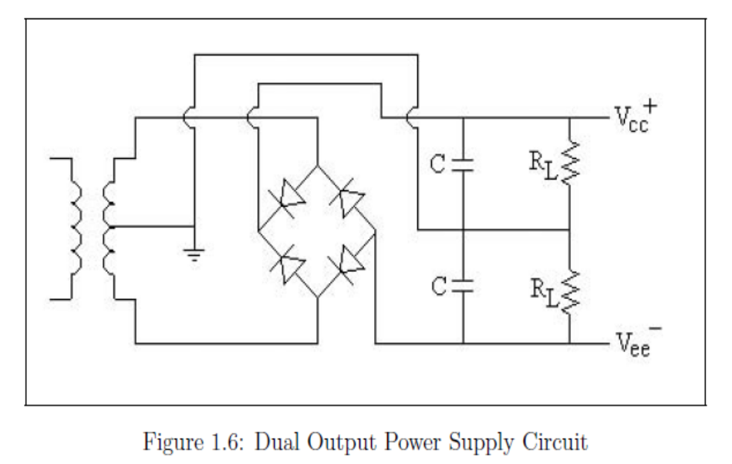
This is the common ground
Attention: This capacitor should have reverse polarity as indicated because 0 is more positive than -ve

Points to Note –
- The capacitor polarity is important here because voltages of opposite polarity are generated by this circuit.
- The top capacitor should have it’s positive (+) connected to “+ve” as shown in the diagram. And negative (-) connected to “0 Volts/GND” as indicated in the circuit.
- The bottom capacitor should have its positive (+) connected to “0 Volts/GND”. And negative (-) connected to “-ve” as shown.
- Note that there is one common ground. The center tap, ends of the resistors and capacitors are all connected to the same common ground.
Common Mistakes –
- The capacitors get burnt when they are not connected as per the polarity shown. So be careful with connecting the capacitors. Ask TA when in doubt.
- The center tap of the transformer is not connected to the common ground which leads to a faulty operation of the circuit. So always connect the center tap to the same ground as the rest of the circuit.

