Laboratory #08 ENEE 148A Fall 2016
In this lab you will work in pairs. You must divide up the code work and each of you indicate which routines you wrote or co-wrote. Complete the following tasks:
Complete the following tasks (This is a TWO-WEEK lab):
- Download and run the code “pwm_test.c”. Have your instructor verify operation.
- Build a circuit that uses the HMC5883L magnetic sensor and the tower pro sg90 servo motor. The sensor must be mounted on the servo; the sensor center of mass may or may not translate as servo rotates (that is for you to decide).
- Write a code that will scan 180ºcontinuously looking for magnets.
  - As long as the detected field is no more than 150% of the earth’s magnetic field, the servo/sensor should continuously scan.
  - When an increase of more than 50% occurs, the servo should point in the direction of the magnet that is causing the change in the magnetic field.
  - If the magnet moves, the servo must move to point correctly.
  - If the magnet is removed, the servo should resume its scan.
  - The code must print an output line each time that a magnet is found indicating the time, the field strength, the angle toward the magnet.
  - Anytime the magnetic strength changes by 50% or the location changes by more than 5º, the code must print a new output line.
- Have your instructor verify successful operation.
EXTRA CREDIT – 30% - if you complete all four tasks above, you can try to use a second magnetic sensor and a multiplexor to cancel out the earth’s magnetic field and improve your device performance (this arrangement is called a gradiometer).
For the write-up of this lab, due 18 November 2016, you need to submit (1) a paper copy of the codes that you wrote and (2) an electronic copy of the codes that you wrote. You also need to draw a diagram of the circuit that you built. Write a summary document of your lab procedure and results of your codes (present and evaluate your results).
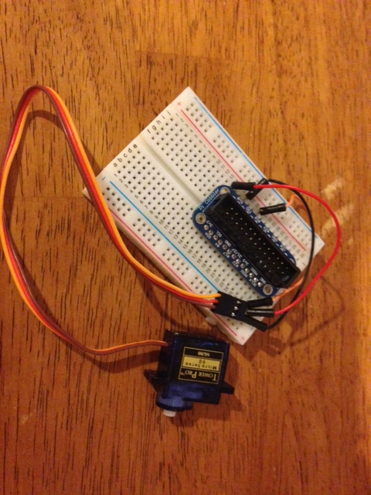
Wire connections:
Red – Vcc – goes to 5V (pin 2)
Brown – ground – goes to pin 6
Orange – PWM control – goes to pin 12

