Laboratory #03 ENEE 148A Fall 2016
This lab is an individual effort! Complete the following tasks:
- Generate and run the program Light_detect.c, after building the necessary circuit.
- Change the code to
  - print to the monitor “light just turned on/off” just once after the sensor changes its state.
  - maintain an LED on while the sensor reads that it is dark out.
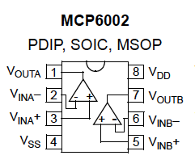
- Have your instructor verify successful operation.
- Change the code to:
  - Get data from two light sensors.
  - print to the monitor “light X just turned on/off” just once after the sensor X changes its state.
  - maintain an LED on while the sensor X reads that it is dark out (for each sensor).
  - print to the monitor “both lights are on/off” just once after both lights enter in the same state (on or off).
  - maintain a third LED on while both sensors read that it is dark out.
- Have your instructor verify successful operation.
For the write-up of this lab, due 7 October 2016, you need to submit (1) a paper copy of the codes that you wrote and (2) an electronic copy of the codes that you wrote. You also need to draw a diagram of the circuit that you built and any pseudocode/flowchart that you made.
